Nama: Dzaki Al Toriq

Kelas: XII PPLG B

Nomer: 13

1. Scalar Subquery

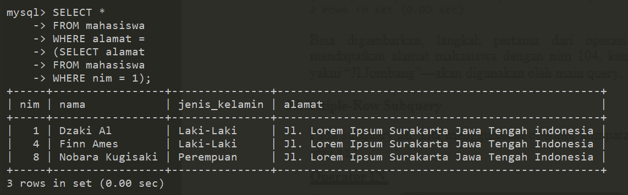

1. Multiple-Row Subquery

* Operator IN

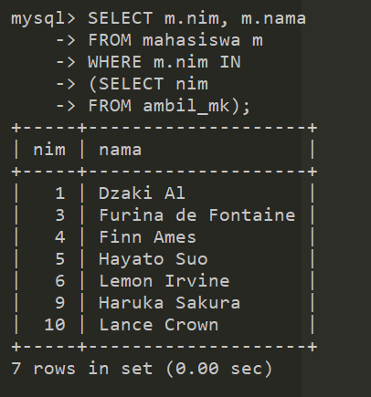

* Operator ANY/SOME

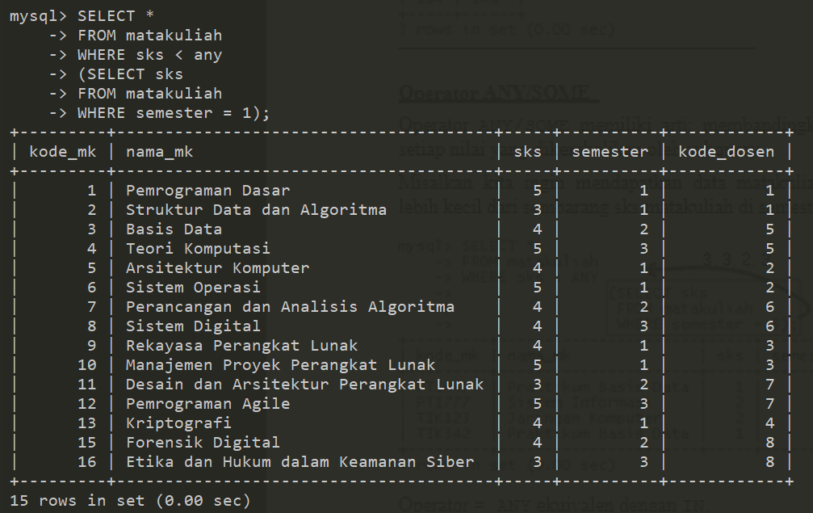

* Operator All

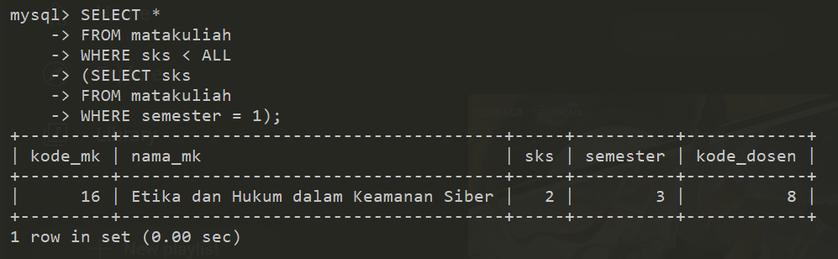

1. Multiple-Column Subquery

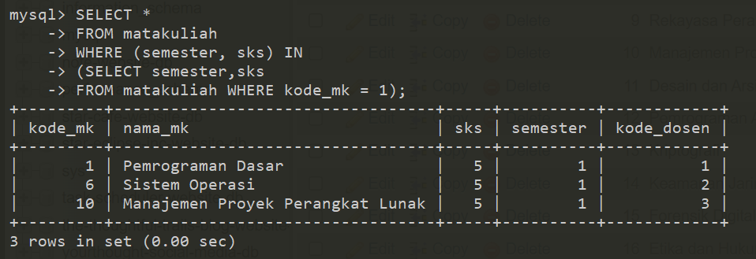

1. Operator EXISTS dan NOT EXISTS

* Exists

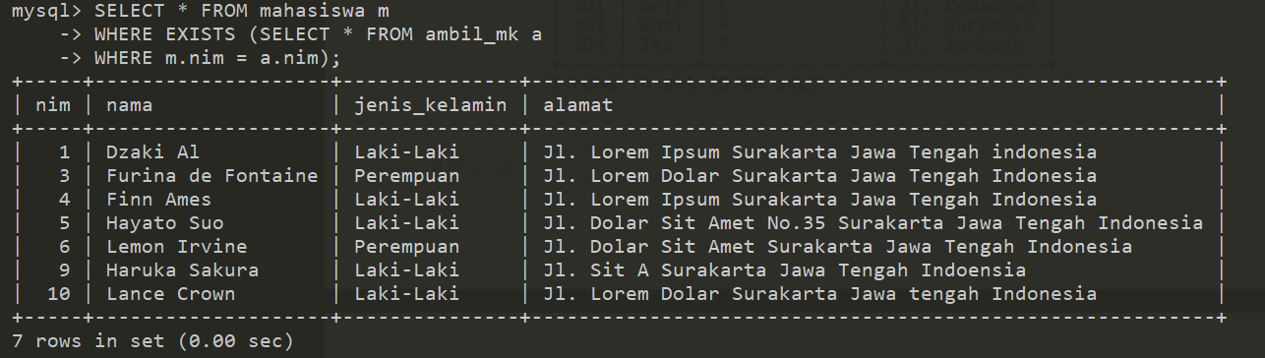

* Not Exists

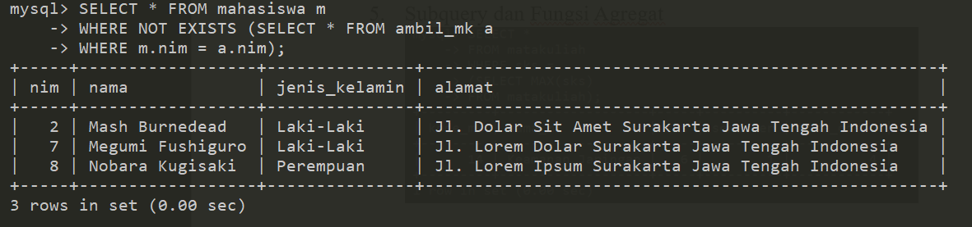

1. Subquery dan Fungsi Agregat

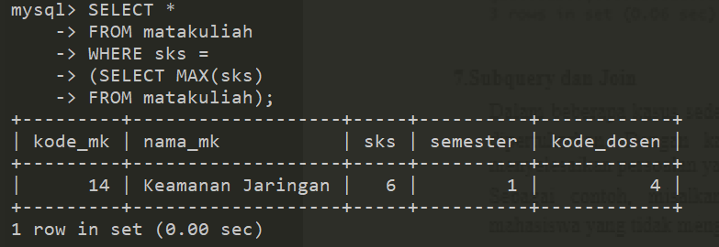

1. Subquery dan Join

* Pendekatan Subquery

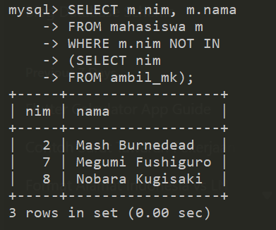

* Pendekatan Join

